Hands On Session
Hello World RESTful Web Service

This is a simple Spring Boot REST application that provides a "Hello World" endpoint.
Project Structure
src/
├── main/
│ ├── java/
│ │ └── com/
│ │ └── cognizant/
│ │ └── springlearn/
│ │ ├── SpringLearnApplication.java
│ │ └── controller/
│ │ └── HelloController.java
│ └── resources/
│ └── application.properties
```

## Requirements
- Java 11 or higher
- Maven 3.6 or higher

## Building the Project
To build the project, run:
```bash
mvn clean package
```

## Running the Application
To run the application, use one of the following methods:
### Method 1: Using Maven
```bash
mvn spring-boot:run
```
### Method 2: Using Java JAR
```bash
java -jar target/spring-learn-1.0.0.jar
```
## Testing the Application
Once the application is running, you can test it using:
### 1. Web Browser
Open your browser and navigate to:
```
http://localhost:8083/hello
```
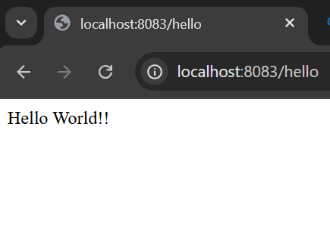

### 2. Postman
- Open Postman
- Create a new GET request
- Set the URL to: `http://localhost:8083/hello`
- Send the request
## Expected Response
The endpoint should return:
```
Hello World!!
```
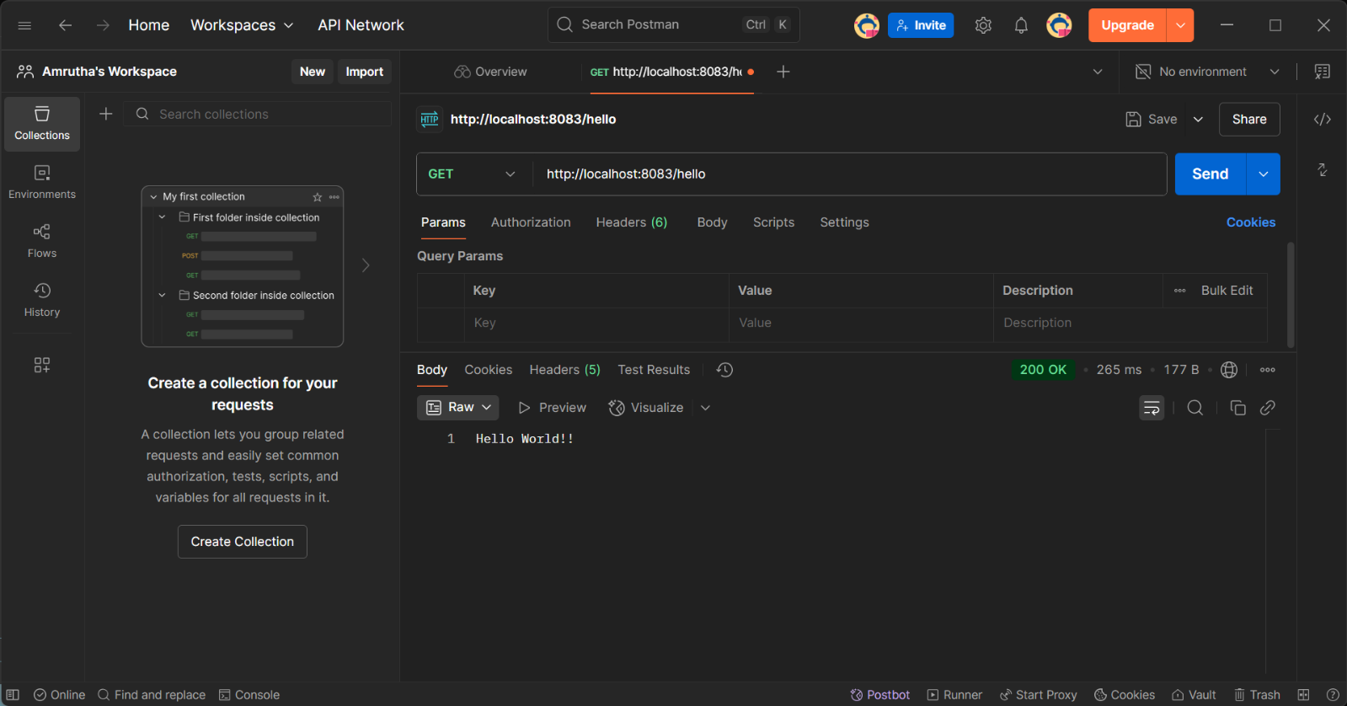

## HTTP Headers
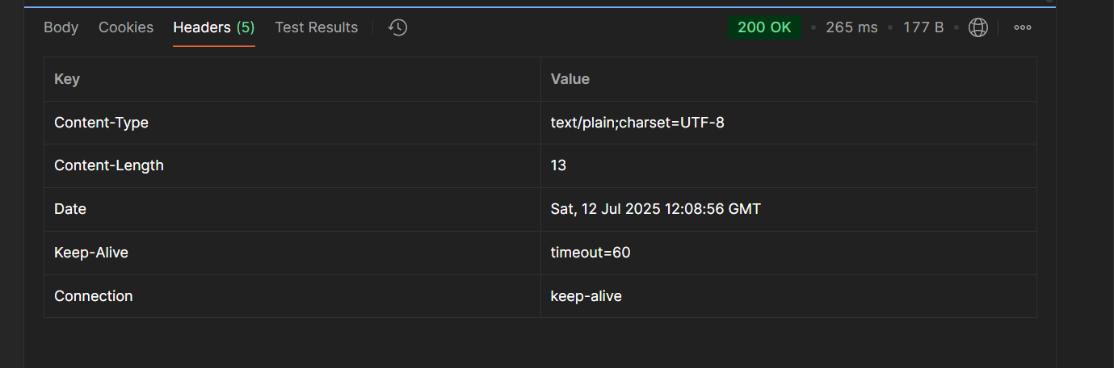
When testing with Postman or browser developer tools, you can view the HTTP headers

## Logging
The application includes logging in the `sayHello()` method:
- START log when the method begins
- END log when the method completes

## API Details
- **Method**: GET
- **URL**: `/hello`
- **Controller**: `com.cognizant.springlearn.controller.HelloController`
- **Method**: `sayHello()`
- **Response**: "Hello World!!"

